# Vue CLI – Guide

## Overview

Vue CLI is a **full system** for rapid Vue.js development, providing:

* Interactive project scaffolding via **@vue/cli**.
* Zero config rapid prototyping via **@vue/cli** + **@vue/cli-service-global**.
* A runtime dependency **(@vue/cli-service**) that is:
  + Upgradeable
  + Built on top of webpack, with sensible defaults
  + Configurable via in-project config file
  + Extensible via plugins
* A rich collection of **official plugins** integrating the best tools in the frontend ecosystem.
* A full **graphical user interface** to create and manage Vue.js projects.

Vue CLI aims to be the standard tooling baseline for the Vue ecosystem. It ensures the various build tools work smoothly together with sensible defaults so you can focus on writing your app instead of spending days wrangling with configurations. At the same time, it still offers the flexibility to tweak the config of each tool without the need for ejecting.

## Installation

### Overview

The CLI (@vue/cli) is a globally installed npm package and provides the vue command in your terminal.

It provides the ability to quickly scaffold a new project via "**vue create"**, or instantly prototype new ideas via "**vue serve"**. You can also manage your projects using a graphical user interface via "**vue ui"**.

### Install Node.js

Vue CLI requires **Node.js** version 8.9 or above (8.11.0+ recommended)

Download from [here](https://nodejs.org/en/).

### Install CLI

To install the new CLI, use one the following command in the **CMD** (run as an **administrator**):

**npm install -g @vue/cli**

Check the CLI version:

**vue --version**

### Install CLI Service

You can rapidly prototype with just a single *.vue file with the "**vue serve**" and "**vue build**" commands, but they require an additional global addon to be installed first:

**npm install -g @vue/cli-service-global**

## Generate a Project

To create a **new project** simply type the following:

**vue create first-project**

A new project can also be generated inside an **existing directory**, like so:

**vue create .**



If no you will be prompted to pick a preset. You can either choose the **default preset** which comes with a basic **Babel + ESLint** setup, or select "Manually select features" to pick the features you need:

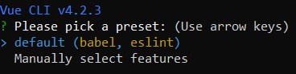

The default setup is great for quickly prototyping a new project, while the manual setup provides **more options** that are likely needed for more **production-oriented** projects:

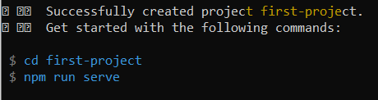

The **vue create** command has a **number of options** and you can explore them all by running:

**vue create --help**

To **start** the **development server**:

**npm run serve**

Open a **browser**, type "**localhost:8080"** and you should see the following:

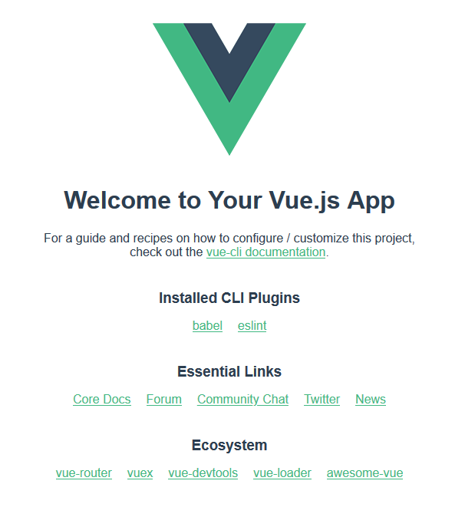

## Vue UI

One particular feature that surely **improves** the workflow of every VueJS developer is Vue UI - a **graphical user interface** enabling you to create, update and **manage** every aspect of your projects.

### Initialization

In order to initialize Vue UI in your current working directory, simply type this command:

**vue ui**

This will automatically open your web browser, and assuming you have no existing projects in your current directory, you should be presented with an interface similar to this:

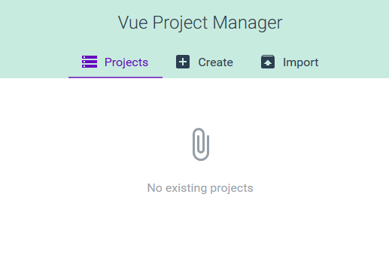

From there on out you can **create new projects** with different configurations, install **plugins**, install **dependencies**, configure the **project/CLI**, run and diagnostic your project tasks and many more.

### Change Language

The Vue UI reads **window.navigator.language** and downloads translations accordingly. To change this, go to your browser's **language preferences** and change the top language to your preferred on (English for most cases):

* Firefox: Settings > General > Language
* Chrome: Settings > Advanced > Languages